Project: Diamond Prices

# Step 1: Understanding the Model

*Answer the following questions:*

1. According to the model, if a diamond is 1 carat heavier than another with the same cut, how much more should I expect to pay? Why?

ANS:

Let’s take example of two 2 diamonds with the same cut and clarity.

Price = -5269 + 8413 * carat + 158.1 * cut + 454 * clarity

Diamond is of 1 carat

Price = -5269 + 8413 * (1) + 158.1 * (2) + 454 *(3) = $4,822.20

Price = -5269 + 8413 * (2) + 158.1 * (2) + 454 *(3) = $13,235.2

Now according to the above example If you are interested in a diamond is 1 carat heavier than another diamond with the same cut and clarity then you have to pay for that diamond is approximately more than double according to it’s carat.

1. If you were interested in a 1.5 carat diamond with a **Very Good** cut (represented by a 3 in the model) and a **VS2** clarity rating (represented by a 5 in the model), how much would the model predict you should pay for it?

ANS:

Price = -5269 + 8413 * carat + 158.1 * cut + 454 * clarity

Price (for 1.5 carat diamond) = -5269 + 8413(1.5)+158.1(3)+454(5)=$10,094.80

For the 1.5 carat diamond, we have to pay approximately $10,094.80 as a retail price and the predicted price for a bid is $7,066.

# Step 2: Visualize the Data

1. Plot 1 - Plot the data for the diamonds in the database, with carat on the x-axis and price on the y-axis.

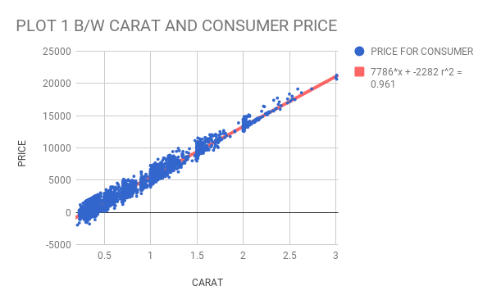

1. Plot 2 - Plot the data for the diamonds for which you are predicting prices with carat on the x-axis and predicted price on the y-axis.

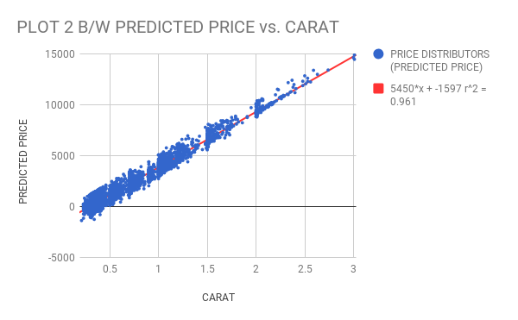

Both sets of data on the same chart in different colors:

3.What strikes you about this comparison? After seeing this plot, do you feel confident in the model’s ability to predict prices?

Ans.

The main differences in Plot 1 and Plot 2 are listed below:

* In Plot 1 the price for 3 carats linearly goes up to 22,000(twenty-two thousand) but in Plot 2 the price for 3 carats linearly goes up to 15,000(fifteen thousand).
* In both plots the regression coefficient is same 0.961but in the combined plot regression coefficient is 0.001.

Step 3: Make a Recommendation

Answer the following questions:

1.What price do you recommend the jewelry company to bid? Please explain how you arrived at that number.

Ans:

According to the price in the given regression model which is calculated by using a formula. This formula is used for the prediction of the price of a particular diamond. The formula includes these all terms like carat, cut, clarity from this formula we can compute the retail price after that from the retail price we can predict or compute the price for a bid of 3,000 diamond set. The predicted bid for 3,000 diamond set is $8,213,465.